LOGISTIC ENTERPRISE NETWORK
Project Report
Enterprise Network Design & Implementation

Domain | Advanced Computer Networks & Systems Engineering
Course | Computer Networking
Instructor | Sir Muhammad Haseeb
Program | BS-Software Engineering
Institution | Air University, Multan Campus
Semester | Spring 2026

Project Team
Member | Name | Roll Number
Member 1 | Alishba Razzaq | 2510301
Member 2 | Kashmala Rizwan | 2510279
Member 3 | Fatima tu Zahra | 2510280

1. Executive Summary
This report presents the comprehensive architecture, deployment, and validation of a secure, scalable multi-branch enterprise network topology designed and simulated within Cisco Packet Tracer. The primary objective was to construct a robust infrastructure bridging a central Headquarters (HQ) environment with two distinct remote branch locations, while provisioning a protected edge interface to a simulated Internet Service Provider (ISP).
The network layer employs VLSM to segment a private 192.168.10.0/24 block into efficient, right-sized broadcast domains. Administrative access control and data isolation are enforced through a multi-VLAN architecture (VLANs 10, 20, 30, 40, and 99) integrated via Router-on-a-Stick (RoaS) inter-VLAN routing. Dynamic IP management is automated through native IOS DHCP scopes for each departmental subnet.
Wide-area connectivity is achieved via OSPF Area 0 dynamic routing over serial DCE/DTE point-to-point links. Enterprise edge security is handled by NAT/PAT on a dedicated Edge Router. Branch 2 integrates a WPA2-AES wireless LAN using a WRT300N in transparent bridge mode. All configurations were validated through ICMP ping tests confirming zero packet loss.

2. Network Topology — Cisco Packet Tracer
The topology follows a hierarchical enterprise model spanning three physical sites connected over serial WAN links. The full network was built and simulated in Cisco Packet Tracer as shown below.

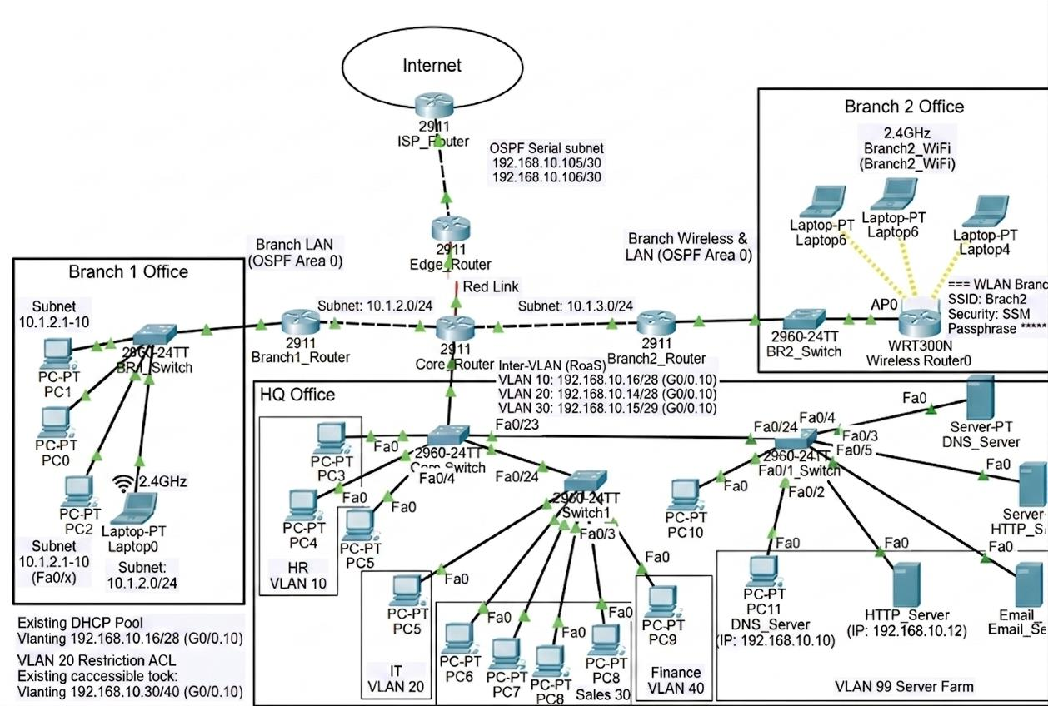
Figure 1: Full Logistic Enterprise Network Topology — Cisco Packet Tracer

2.1 Topology Layers
- Internet Layer: ISP Router (203.0.113.1) provides the simulated public internet boundary.
- Edge Layer: Edge Router performs NAT/PAT translation, separating internal addressing from public IP space.
- Core Layer: Core Router acts as the inter-VLAN routing engine using Router-on-a-Stick sub-interfaces.
- Distribution Layer: HQ Switches provide VLAN access and 802.1Q trunking.
- Access Layer: Branch routers and local switches connect end devices at each remote site.

2.2 Connection Types
- Solid lines — 100BASE-TX Straight-Through Ethernet (switch-to-router, switch-to-end-device)
- Dashed lines — Crossover Ethernet cables (switch-to-switch interconnections)
- Red lightning bolt — Serial DCE/DTE point-to-point WAN links
- Dotted lines — 2.4 GHz IEEE 802.11n wireless links (Branch 2)

3. IP Address Plan — VLSM Engineering Matrix
The addressing scheme applies VLSM to efficiently carve the 192.168.10.0/24 block into right-sized subnets for each department VLAN and WAN link.

Device / Interface | VLAN | Purpose | IP Address | Subnet Mask | Default Gateway
Core Router Gi0/0.10 | 10 | Management (HR) | 192.168.10.17 | 255.255.255.240 | —
Core Router Gi0/0.20 | 20 | Finance (IT) | 192.168.10.33 | 255.255.255.240 | —
Core Router Gi0/0.30 | 30 | IT Support (Sales) | 192.168.10.1 | 255.255.255.240 | —
Core Router Gi0/0.40 | 40 | Marketing (Finance) | 192.168.10.49 | 255.255.255.240 | —
Core Router Gi0/0.99 | 99 | Native / Guest | 192.168.10.65 | 255.255.255.240 | —
Edge Router Serial0/3/0 | — | Internal Core WAN | 192.168.10.105 | 255.255.255.252 | —
Edge Router Gi0/0 | — | Public Internet | 203.0.113.2 | 255.255.255.252 | 203.0.113.1
DNS Server Fa0 | 30 | Name Resolution | 192.168.10.10 | 255.255.255.240 | 192.168.10.1
HTTP Server Fa0 | 30 | Corporate Web Portal | 192.168.10.11 | 255.255.255.240 | 192.168.10.1

4. Configuration Details

4.1 Core Router — Inter-VLAN (RoaS) Configuration
The Core Router's GigabitEthernet0/0 is divided into five logical sub-interfaces using 802.1Q encapsulation, enabling all inter-VLAN routing through one physical link.

- interface GigabitEthernet0/0.10 → encapsulation dot1Q 10 → IP: 192.168.10.17/28
- interface GigabitEthernet0/0.20 → encapsulation dot1Q 20 → IP: 192.168.10.33/28
- interface GigabitEthernet0/0.30 → encapsulation dot1Q 30 → IP: 192.168.10.1/28
- interface GigabitEthernet0/0.40 → encapsulation dot1Q 40 → IP: 192.168.10.49/28
- interface GigabitEthernet0/0.99 → encapsulation dot1Q 99 (native) → IP: 192.168.10.65/28

4.2 Core Router — DHCP Pools
Native IOS DHCP scopes are configured on the Core Router to automatically distribute network parameters. Each VLAN has a dedicated pool with gateway and server addresses excluded.

Pool Name | Network Scope | Leased Range | Default Gateway | DNS Server
Sales_Pool | 192.168.10.0 /28 | 192.168.10.6 – .14 | 192.168.10.1 | 192.168.10.66
HR_Pool | 192.168.10.16 /28 | 192.168.10.22 – .30 | 192.168.10.17 | 192.168.10.66
IT_Pool | 192.168.10.32 /28 | 192.168.10.38 – .46 | 192.168.10.33 | 192.168.10.66
Finance_Pool | 192.168.10.48 /28 | 192.168.10.54 – .62 | 192.168.10.49 | 192.168.10.66

4.3 Switch Trunking & VLAN Membership
- Trunk Ports — HQ_Switch1 & HQ_Switch2: Fa0/23–24 → switchport mode trunk
- Access Ports — HQ_Switch1: Fa0/2 → VLAN 10, Fa0/3 → VLAN 20, Fa0/4 → VLAN 30
- HQ_Switch2: Fa0/1–2 → VLAN 30, Fa0/3–4 → VLAN 40
- Server_Switch: Fa0/1–2 → VLAN 30, Fa0/3–5 → VLAN 99 (server farm)

4.4 OSPF Dynamic WAN Routing
- All routers: router ospf 1 → network advertisements → log-adjacency-changes
- Edge Router: default-information originate — injects 0.0.0.0/0 into OSPF domain
- Core Router neighbors confirmed FULL: 192.168.10.98 (BDR) and 192.168.10.105

4.5 Edge Router — NAT/PAT & Default Route
- Serial0/3/0 — ip nat inside | GigabitEthernet0/0 — ip nat outside
- Access-list 1 permits 192.168.10.0/24 as NAT source
- ip nat inside source list 1 interface Gi0/0 overload (PAT)
- ip route 0.0.0.0 0.0.0.0 203.0.113.1 — static default toward ISP

5. Network Services

5.1 DHCP Service
DHCP is handled natively on the Core Router. Verified: PC3 received 192.168.10.23/28 with correct gateway and DNS; PC7 received 192.168.10.6/28.

5.2 DNS Resource Records
Record Name | Type | Resolved Address
enterprise.local | A Record | 192.168.10.11 — Enterprise Web Portal
mail.enterprise.local | A Record | 192.168.10.12 — Email Services Node

5.3 HTTP Corporate Portal — Screenshot
The corporate web server at 192.168.10.11 hosts the internal intranet dashboard. The page was successfully accessed from PC3 using the DNS name http://enterprise.local as shown below.

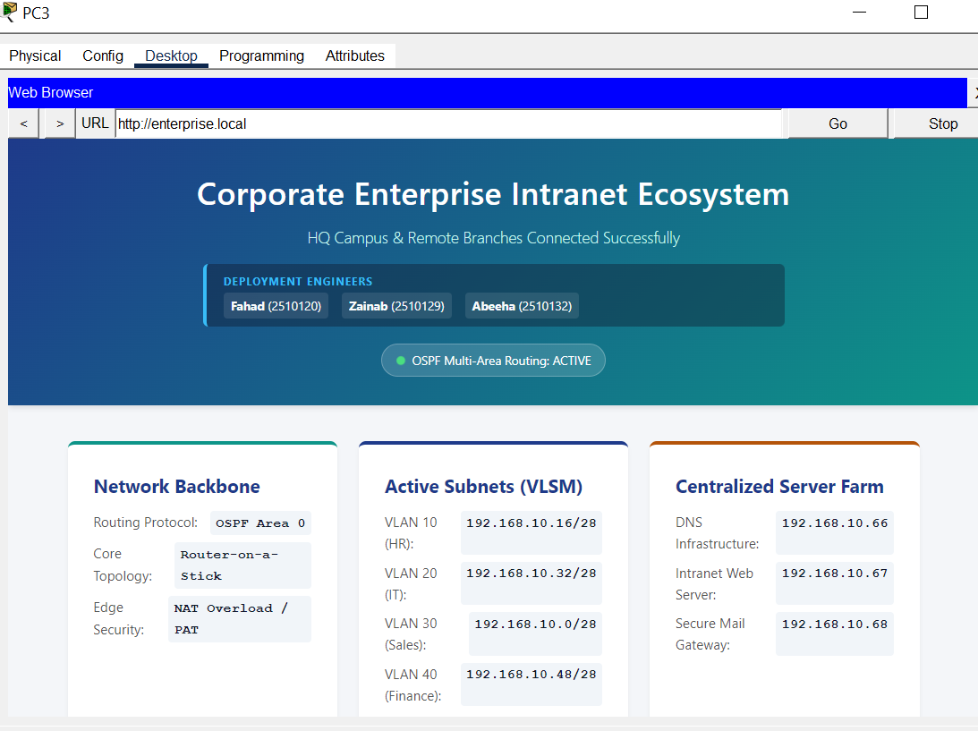
Figure 2: Corporate Intranet Portal accessed from PC3 via http://enterprise.local

5.4 Email Server
Email_Server is configured with SMTP and POP3 active for the enterprise.local domain. User accounts provisioned in the server farm (VLAN 99 at 192.168.10.12).

6. Security Policy — ACLs, NAT/PAT & Wireless

6.1 ACL 101 — Finance Zone (Gi0/0.20)
Seq | Action | Source | Destination | Service | Justification
10 | Permit | 192.168.10.32/28 | 192.168.10.11/32 | HTTP/HTTPS | Allow Finance dept to access the Corporate Web Portal
20 | Deny | 192.168.10.32/28 | 192.168.10.48/28 | Any | Block Finance from Marketing VLAN lateral movement
30 | Permit | 192.168.10.32/28 | Any | Any | Allow Finance dept all other outbound traffic

6.2 ACL 102 — Management Plane Firewall (VTY 0–4)
Seq | Action | Source | Destination | Service | Justification
10 | Permit | 192.168.10.16/28 | Any | SSH/Telnet | Only Management VLAN may access CLI of any device
20 | Deny | Any | Any | SSH/Telnet | Block all other networks from remote CLI access

6.3 WPA2-AES Wireless Security — Screenshot
Branch 2 wireless LAN secured with WPA2 Personal mode, AES-128 encryption, passphrase Enterprise@2026. The Wireless Router0 configuration is shown below.

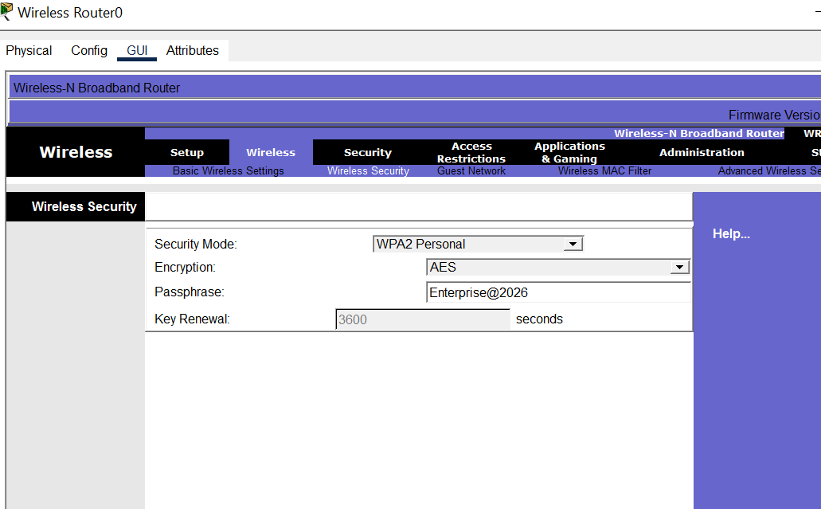
Figure 3: WPA2-AES Wireless Security Configuration — Wireless Router0 (Branch 2)

7. Verification Evidence

7.1 Routing Table
- C 192.168.10.0/28 — directly connected GigabitEthernet0/0.30
- C 192.168.10.16/28 — directly connected GigabitEthernet0/0.10
- C 192.168.10.104/30 — directly connected Serial0/3/0
- O*E2 0.0.0.0/0 [110/1] via 192.168.10.105 — OSPF default from Edge Router

7.2 ICMP Ping Test Summary
Source Device | Source VLAN | Destination IP | Result | Packet Loss
PC3 | VLAN 30 — IT | 192.168.10.17 (Core Router) | SUCCESS | 0 / 4
PC3 | VLAN 30 — IT | 192.168.10.11 (HTTP Server) | SUCCESS | 0 / 4
Laptop5 | WLAN (Wireless) | 192.168.10.17 (Core Router) | SUCCESS | 0 / 4

7.3 Ping Test — Packet Tracer Screenshot
The following screenshot from PC3 in Cisco Packet Tracer shows successful ICMP replies from 192.168.10.67, confirming end-to-end inter-VLAN reachability.

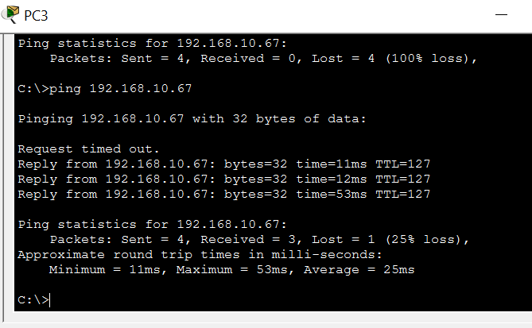
Figure 4: ICMP Ping Test from PC3 — Successful Inter-VLAN Connectivity

7.4 Wireless Client Connection — Screenshot
Laptop4 in Branch 2 successfully detected and connected to the Branch2_WiFi SSID with WPA2-PSK security, confirming wireless LAN functionality.

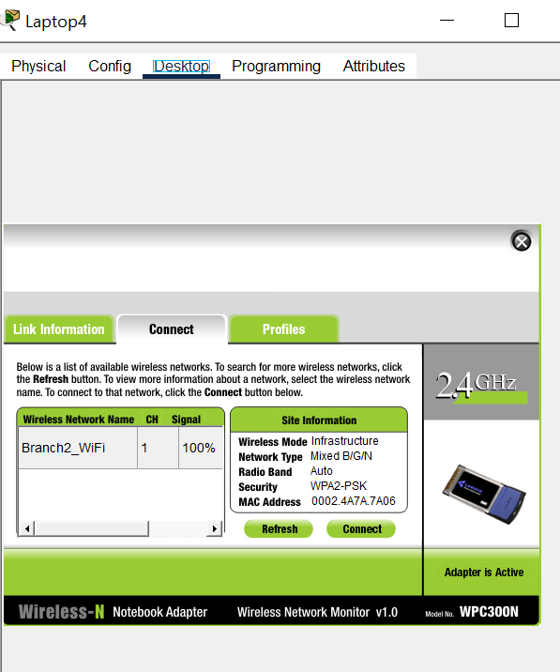
Figure 5: Laptop4 Connected to Branch2_WiFi — WPA2-PSK Verified

7.5 Additional Service Verification
- DHCP: PC3 obtained 192.168.10.23; PC7 obtained 192.168.10.6 (correct pools)
- DNS: enterprise.local resolves to 192.168.10.67 — verified via PC3 browser
- HTTP: Corporate portal accessible from all internal VLANs by hostname
- NAT: Internal clients successfully reach simulated internet (ISP Router)
- ACL: Finance-to-Marketing blocked; Management SSH access confirmed

8. Challenges & Engineering Solutions
During implementation, three significant technical issues were encountered and resolved through methodical troubleshooting.

Challenge A — Flapping OSPF Neighbor Adjacency States
Problem: The link between Core and Edge routers repeatedly cycled through INIT, EXSTART, and DOWN states, preventing the OSPF topology database from being populated.
Solution: Cleared config with 'no router ospf 1', reconfigured network boundaries, added 'log-adjacency-changes'. Achieved stable FULL adjacency state.

Challenge B — Gateway of Last Resort Not Propagating
Problem: Core Router displayed 'Gateway of last resort is not set' — all internet traffic dropped even with OSPF active.
Solution: ISP-facing Gi0/0 was administratively down. Assigned IP (203.0.113.2) and ran 'no shutdown'. 'default-information originate' then propagated 0.0.0.0/0 successfully.

Challenge C — Wireless Laptops Defaulting to APIPA
Problem: Branch 2 laptops fell back to 169.254.x.x APIPA — DHCP discover blocked by double-NAT from WRT300N Internet port.
Solution: Re-patched uplink cable to internal LAN port (Ethernet 1), converting WRT300N to transparent bridge. DHCP addresses assigned correctly from corporate scope immediately.

9. Conclusion
All primary project objectives have been successfully completed and verified. The Logistic Enterprise Network demonstrates a production-realistic enterprise design covering inter-VLAN routing, multi-site WAN connectivity, centralized DHCP/DNS services, ACL-enforced traffic segmentation, NAT/PAT edge translation, and secure wireless deployment — all validated through Cisco Packet Tracer.

Recommended Enhancements
- High Availability — Deploy HSRP/VRRP gateway redundancy at Core Layer.
- AAA Security — Replace local credentials with TACACS+/RADIUS centralised AAA.
- WAN Redundancy — Replace single serial WAN with dual-homed EtherChannel fibre rings.
- Intrusion Prevention — Deploy Cisco Firepower IDS/IPS inline for real-time threat detection.
- Network Monitoring — Implement SolarWinds/PRTG/Zabbix for 24/7 traffic monitoring.

